**Politecnico di Milano**

**5th School of Engineering**



Big Gym

Hypermedia Applications (Web and Multimedia) Project

# **IDM C/L/P D**esign **D**ocument

**Nemanja Stolic 814842**

**Mirjam Skarica 836505**

Contents

**IDM C/L/P D**esign **D**ocument 1

1. Introduction 2

1.1. Purpose 2

# Purpose

This document aims to describe the design and prototyping steps taken for “Big Gym” web application assigned as part of a project of the “Hypermedia Applications (Web and Multimedia)” course at Politecnico di Milano.

# Brief introduction

The document provides detailed web application development procedure. Starting from the conceptual design, upgrading it to logical design and, finally, page design. After page design is introduced, it is going serve as the basis for interactive mockup development and will be described at the end of this document. In order to declutter and keep the document on point, we have left out the legend i.e. the meaning of all the symbols used in schemas and decided to treat it as a given. Explanation of all the symbols used can be found in the course's lesson slides.

# Conceptual design (C-IDM)

Conceptual design is made with respect to the specifications published in the reference document “BIG_GYM_project_HYP2014-15-Beep-V2” that was provided by professor Franca Garzotto.

Short outline:

**SINGLE TOPICS**

**1. OUR GYM**

**2. Location**

**3. Testimonials**

**4. Overall schedule**

**5. FEEs and registration**

**6. Our Equipment**

**MULTIPLE TOPICS**

**1. Instructor [10-30]**

**2. Course [20-50]**

**3. Course category [10]**

**4. “Room” [10]**

**RELATIONSHIPS**

**1. Offer: Course category** →**Course [5, 10]**

**2. Belongs-to: Course** → **Course category [1]**

**3. Staff_1: Course -> Instructor [1-2]**

**4. Teaches_1: Instructor -> Course [3-6]**

**5. Staff_2: Course category -> Instructor [2, 5]**

**6. Teaches_2: Instructor -> Course Category[1-2]**

**7. Where: Course -> “Room”[1-1]**

**8. Held-here: “Room”-> Course [5-10]**

**MULTIPLE GROUPS**

**1. COURSES by *COURSE CATEGORY* [10]**

**GROUPS**

**1. ALL INSTRUCTORS**

**2. ALL “ROOMS”**

**3. ALL COURSES – Alphabetic order**

**4. ALL COURSES – By- Level**

**5. ALL COURSE CATEGORIES**

**6. INSTRUCTORS OF THE MONTH**

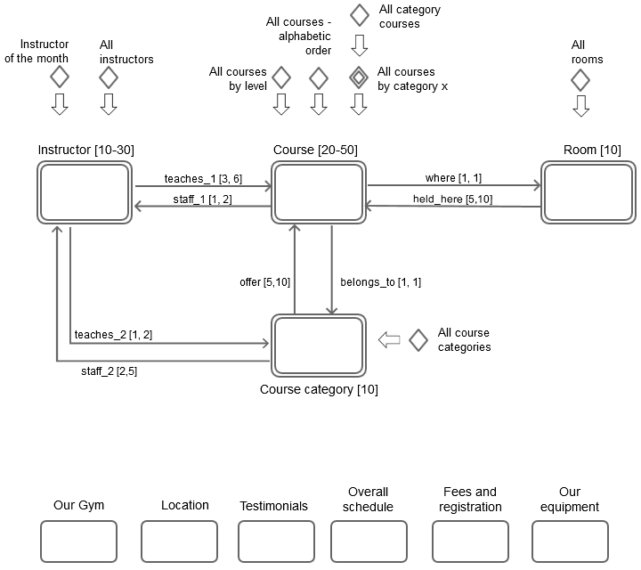

Figure 3.1 - Conceptual IDM schema

What is worth noting is that there is one Multiple Group of Topics (abbr. MGoT), “*All courses by category X*”, where X is parameter which needs to be specified by the user. Once the user specifies X, e.g. X=”Yoga”, “All course categories” will show all courses that are in specified category (in our case, all courses in Yoga). Other elements of C-IDM are pretty much self explanatory by their appearance in the scheme.

# Logical Design (L-IDM)

Logical design enhance C-IDM scheme by introducing content dialogue acts. Content dialogue acts can be perceived as Question and Answer form of interaction with the user. User asks the question about the content, and the system (web application) returns the contents that user asked for. Short outline:

**SINGLE TOPICS**

**1. BIG GYM**

• *A DIFFERENT PLACE*

• *OUR HISTORY*

• *OUR SPACES*

o *INFO_REQUEST*

**2. LOCATION**

• *WHERE*

• *CONTACT US*

**3. Testimonials**

• *TESTIMONIALS*

**4. Our equipment**

• *THE BEST EQUIPMENT*

**5. Overall schedule**

• *OVERALL SCHEDULE*

**6. FEEs and registration**

• *REGISTRATION INSTRUCTIONS*

• *OUR RATES*

o *REGISTER*

**MULTIPLE TOPICS**

**1. Instructor [10-30]**

• INSTRUCTOR

• [AWARDS]

**2. Course category [10]**

• COURSE CATEGORY

**3. Course [20-50]**

• COURSE DESCRIPTION

• SCHEDULING

o REGISTER

We may pay attention to both, content dialogue acts which further describe our topics and multiple topics, in L-IDM schema (*fig 4.1.*), and to Relevant Relations that have cardinality value greater than one. Relevant relations that have cardinality equal to one are simple to implement, one simple link leading to other side of relation. The ones with cardinality greater than one require an additional transitional page in P-IDM schema. More about it in the next section.

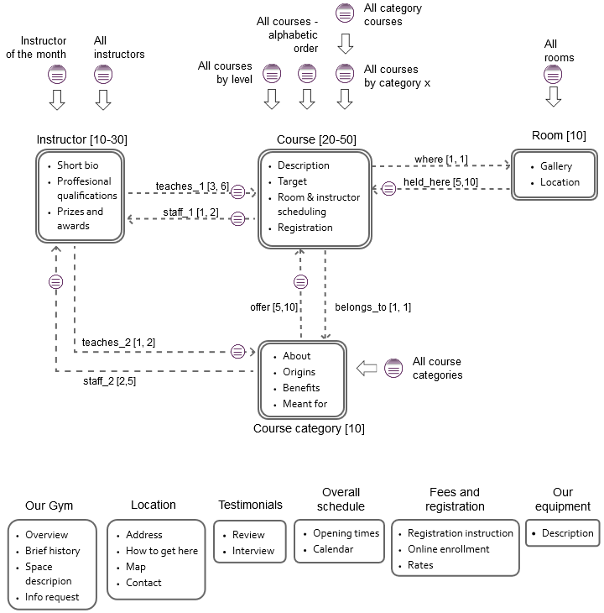

Figure 4.1 - Logical IDM schema

# Page design (P-IDM)

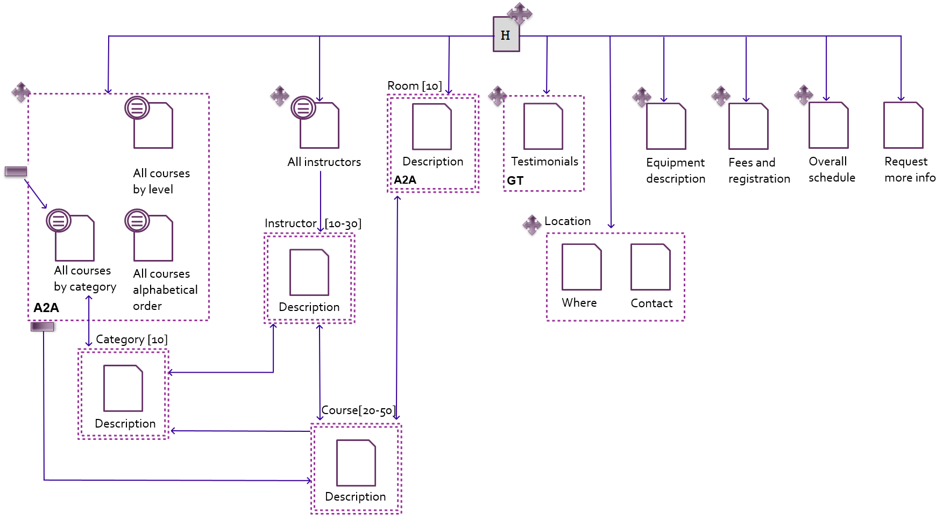Figure 5.1 - Page IDM schema

In P-IDM our attention is focused on the implementation of our web application. We need to convert entities from L-IDM schema to real html pages (at least to their high-level structures) and navigation links that will constitute our P-IDM schema. The cross symbol next to page represents that page is a landmark, that is, a page that is always accessible through navigation menu no matter on which page we are positioned. For simple pages on the right there is not much to say, but some pages on the left require a more thorough explanation.

For example, a group of pages on the leftmost side in a dashed rectangle are also a landmark. Once user clicks on that landmark he lands on the default page “*All courses by category*”, as it is denoted by the pointing arrow. That page is a transition page which shows all categories and their respective courses. The user can click on some of the categories and he will be navigated to page “*Category*” where he can get more information about the concrete category and instructors that teach courses for that category. Concrete instructor can be reached from that page or from landmarked transitional page “*All instructors*”. This dashed group has the A2A pattern, which means that all pages in a group are connected by navigational links among each other.

Testimonials are represented as a regular Topic page, except that they have navigational pattern “Guided tour” implemented for scrolling among concrete testimonials.

(Concrete) Rooms are also represented as a Topic page, and in addition they are fully connected among each other (A2A). Each concrete room page is accessible from any other.

Somebody may ask why there are single pages in a dashed group (e.g. Course, Category, Instructor, and Room). Those are pages that have cardinality greater than one, implying that there are multiple pages of the same type grouped in our rectangle.

Observing navigational arrows, we can notice that some of them are unidirectional and some of them are bidirectional. The bidirectional link provides us the possibility to return back to the page from where we came.

# Interactive Mockup

As the last step in the design process, we derive an interactive mockup from P-IDM (*fig 5.1.*) keeping in mind the goals of our proverbial contractors, owners of Big Gym (promotion and conveying information clearly) and that of our end-users, Big Gym's clients (getting all their questions answered). For the sake of readability all images will be a smaller than original size. You can, however, find a full interactive mockup in html format in the *./HTML/* subdirectory.

Starting with the *Home Page* (fig 6.1), right below the web application's title is a navigation bar incorporating all landmark pages stated in P-IDM as navigation links. The same navigation element is used across all pages, and as such won't be mentioned in the sections that follow. Along with some descriptive elements like "*A different place*" and "*Our History*", *Home Page* also contains links "*Request more info*" and "*For a detailed layout click here*" which serve the user a popup contact form with optional newsletter subscription (*fig 6.2* ) and the *Rooms Page* (*fig 6.3*) respectively.

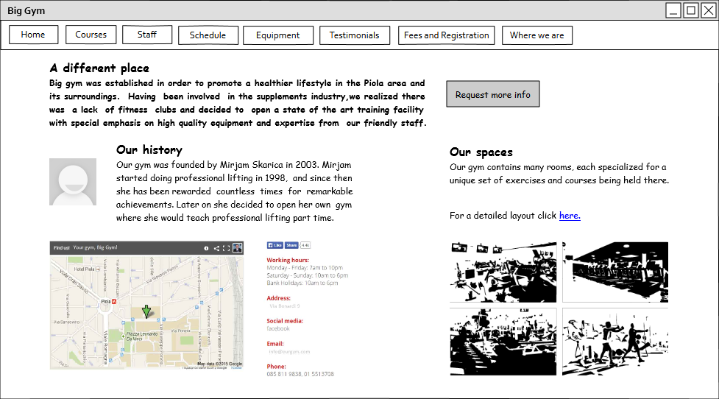

Figure 6.1 Home Page

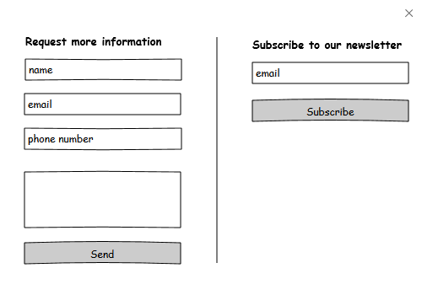

Figure 6.2 Request more information popup

*Rooms Pag*e, even though not a landmark remains reachable from *Home Page* and individual *Course Pages.* Keeping in mind *Rooms* conceptually are a set of pages (and thus shown as a multiple topic in P-IDM), we have made a somewhat different design choice in order to complement the increasingly more popular dynamic feel and flow of content. We try to achieve this by having not multiple, but one page containing information about all of the different rooms. To clarify further, the page *contains* all information, but only one room's content is *displayed* at a time. We used the all-to-all navigation pattern to implement this seamlessly. By selecting/switching through tabs ( namely *room A1, room A2, room A3* in the *fig 6.3)* a different room's content is rendered dynamically. Each *Room* contains a map with its location highlighted, a gallery of photos and links to particular *Courses* held there.

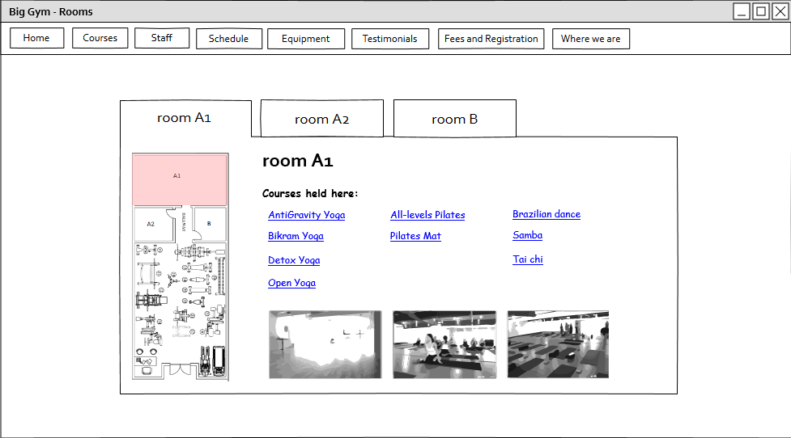

Figure 6.3 Rooms Page

*Staff Page*  (*fig 6.4*)denoted as *All instructors* in P-IDM is a page consisting only of transitional links. More specifically, each compound element, a picture and text below representing instructor's name, leads to a corresponding single *Instructor Page (fig 6.5)*.

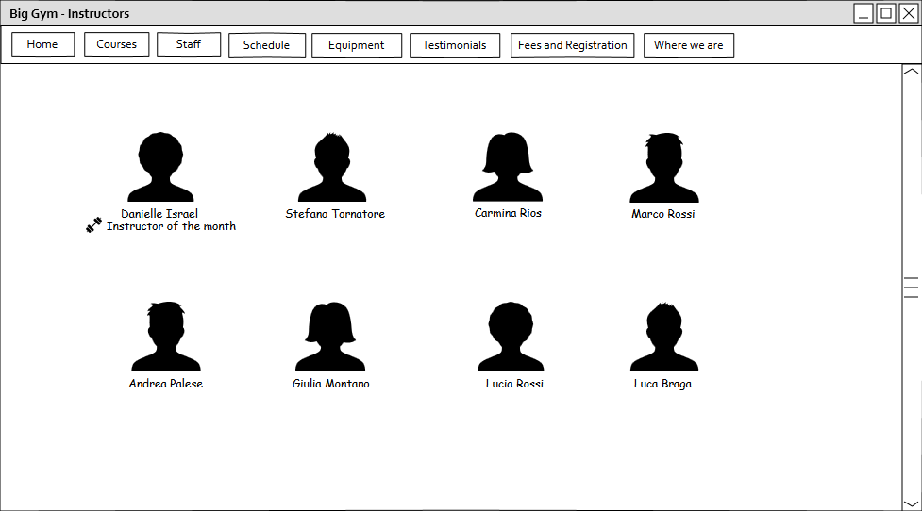

Figure 6.4 Staff Page

*Instructor Page* shown in *fig 6.5* is a page displaying specific instructor's name, bio, professional qualifications and awards. It also lists all the courses and corresponding categories the instructor teaches. Every list item is a transitional link which redirects the user upon click to a specific *Course (fig 6.8)* or *Category (fig 6.7)*. *Instructor Page* is reachable from either *Staff Page,* specific *Course* or *Category*.

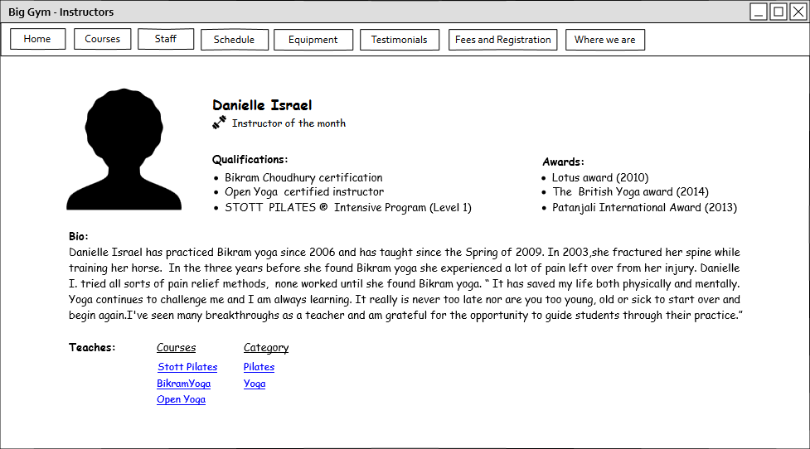

Figure 6.5 Instructor page

*Courses Page,* shown in *fig 6.6,* is a page heavily influenced and guided by the same dynamic content flow motivations argued in the *Rooms Page* paragraph*.* The rationale for *Courses Page* design choices follows. There is a finite set of specific single courses Big Gym is offering. Each course belongs to a category, level and, of course, has a name, meaning it intrinsically has a unique position in alphabetical ordering of all courses. That being said, it is easy to realize that the three pages of transitional links namely *Courses by category*, *Courses by level* and *Courses by alphabetical order* would basically have the *same* content (list of courses) just *visually* grouped and labelled differently. This is why we decided to merge the three pages into a single one practically. Conceptually though, they behave as 3 separate entities connected via all-to-all navigation pattern implemented as 3 tabs. All tabs behave in a similar way. They render labelled boxes (e.g. *Cardio* and *Dance* for Category, *Beginner* and *Intermediate* for Level and *A,B* for Alphabetical ordering) and in them a list of links redirecting user to a specific course (*fig 6.8*) upon click. The only tab that provides a piece of additional information is the *Category* one. Next to each label there is a link in shape of a circled *"i"* which redirects user to a specific *Category Page* *(fig 6.7*).

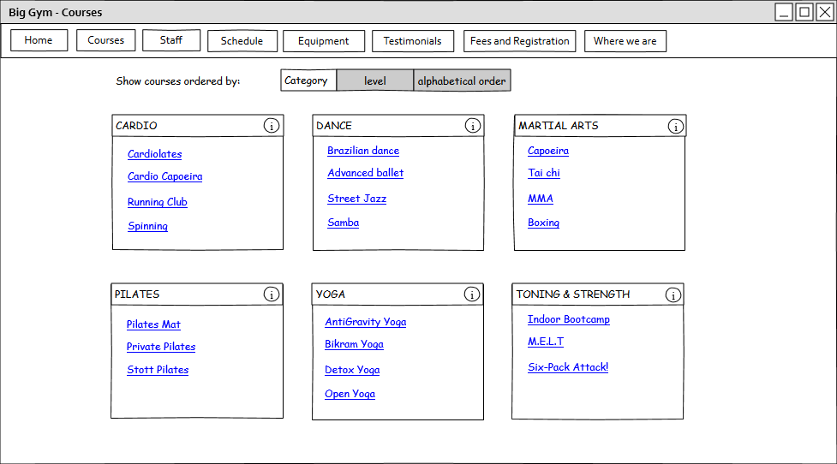

Figure 6.6 Courses Page

*Category Page* (*fig 6.7)* is reachable from the *Courses Pag*e (*Category* tab), specific *Instructor Page* and specific *Course Page.* It consists of simple text elements providing some general information about it's origins and benefits. Moreover, it has the following links. One for listing all courses of that specific category which redirects user to *Courses Pag*e (*Category* tab). Others for listing all instructors which teach at least one course of that category. Clicking on an instructor link serves the user the intructor's page (*fig 6.5*).

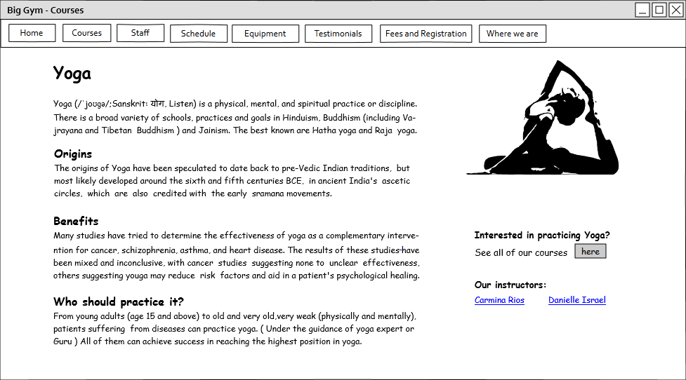

Figure 6.7 Category Page

*Course Page* shown in *fig 6.8* is a page providing information about the length of the course, expectations and schedule. It also provides information about its category, about which rooms it takes place in and which instructors teach it; all this in the form of links. Additionally it has a form through which users can quickly and simply enroll in the course. *Course Page* is reachable from either *Instructor Page, Courses Page,* specific *Category* or *Room page*.

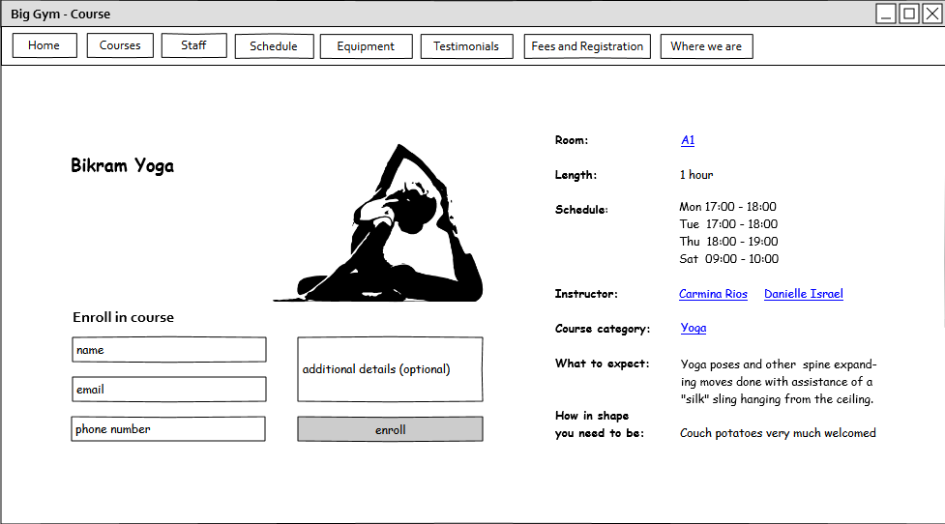

Figure 6.8 Course Page

Testimonials Page (*fig 6.9*) is a page consisting of 4 video reviews alongside some information explaining what can be expected from the videos which are made navigable using the guided tour pattern.  
  
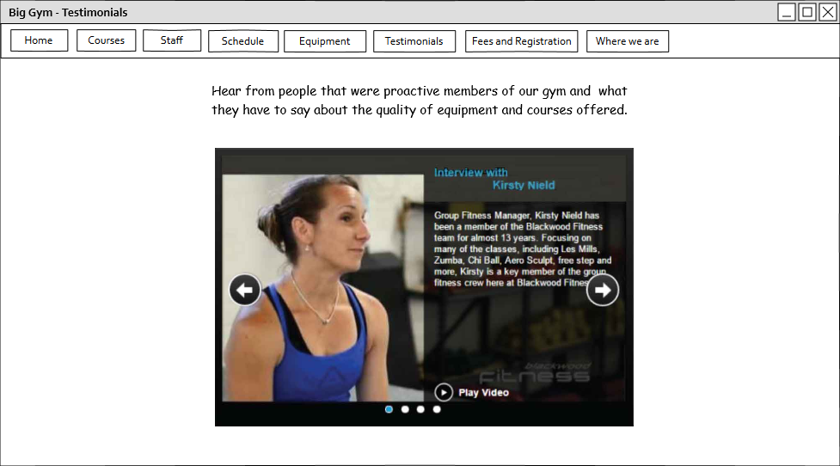

Figure 6.9 Testimonials Page

Part from the fact *Location Page* and *Fees and Registration Page* embed contact and registration forms, respectively, *figures 6.10-6.13* are not in need of extensive descriptions as they don't utilize any specific navigational patterns, nor were any specific design decisions made. They are included in this document for completeness.

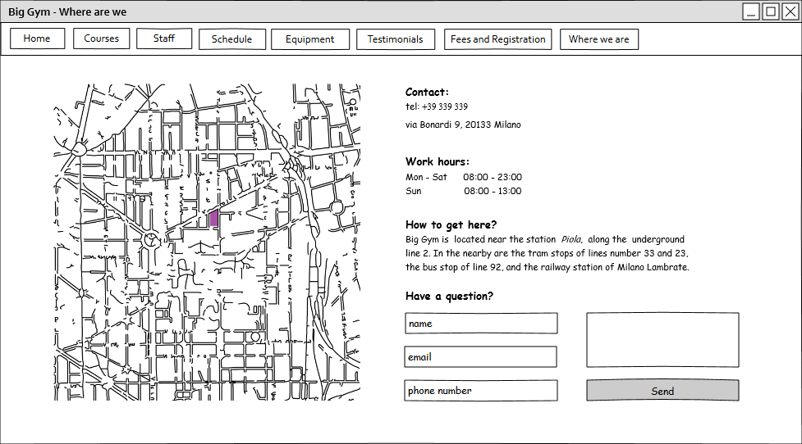

Figure 6.10 Location Page

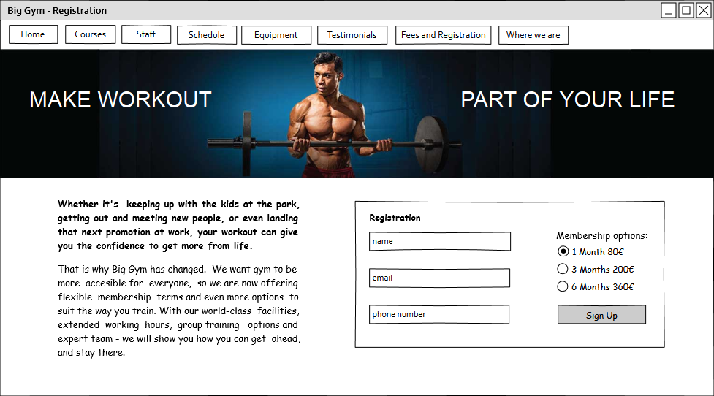

Figure 6.11 Fees and Registration Page

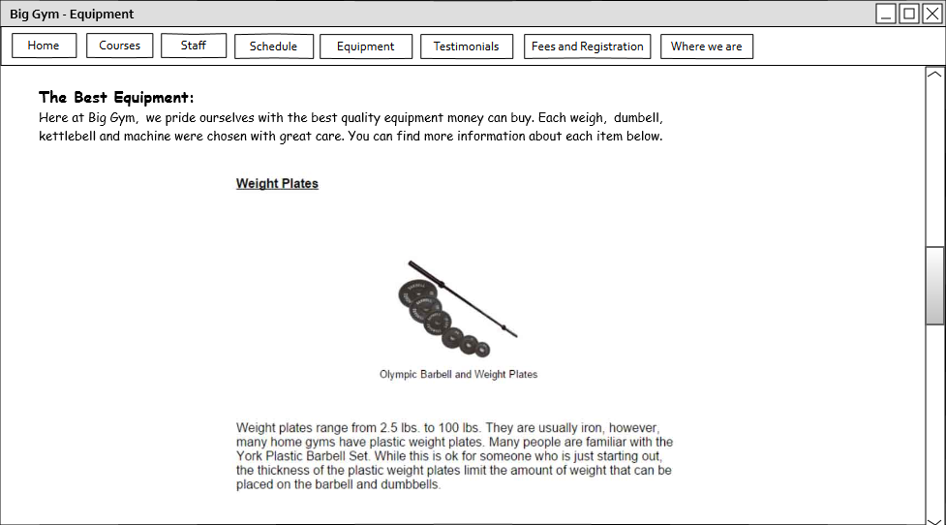

Figure 6.12 Equipment Page

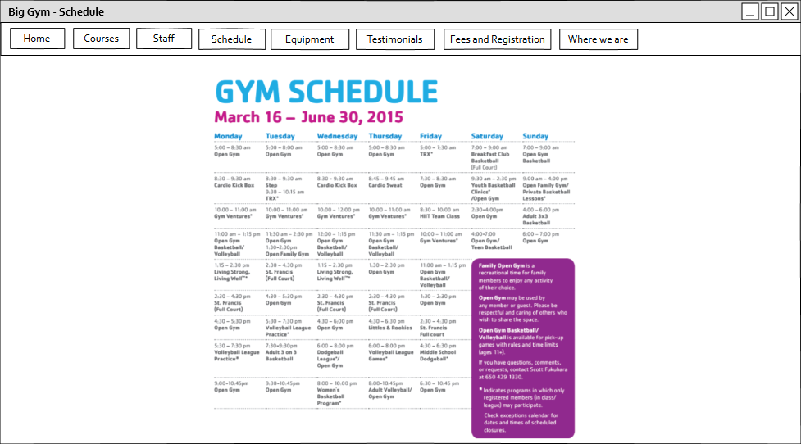

Figure 6.14 Schedule Page

# Used tools:

* Microsoft Office Word
* Adobe Illustrator
* Evolus Pencil

# Working Hours

|  |  |
| --- | --- |
| **Name** | **Working hours** |
| Nemanja Stolic | 20 hours |
| Mirjam Skarica | 20 hours |